
Pre-AP Biology
Unit 7 – Evolution
Suggested Duration: 13 Days

EVOLUTION
UNIT PLAN

Table of Contents
UNIT NARRATIVE 1
CONTENT STANDARDS 2
UNDERSTANDINGS AND QUESTIONS 2
ROADMAP 4
UNPACKED STANDARDS 14

UNIT NARRATIVE
This unit deals with concepts related to the concept of evolution. We start the unit off with an investigation of what natural selection using a hands-on-minds-on activity where students model the change of gene frequencies over time. Then, they use an online simulation from PhET to investigate how a population of bunnies evolves over time due to mutations and changes in the environment. Students then engage in two activities where they model how similarities and differences in traits among different species can indicate a common ancestor. This leads into two activities where students investigate the different types of evidence used to support the concept of evolution. Students end the unit with a study of how one species is able to evolve over time into two or more different species (speciation).

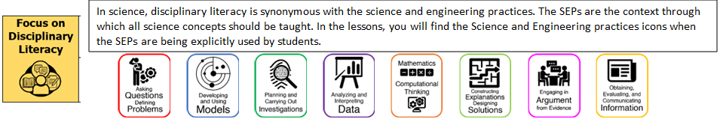

CONTENT STANDARDS
Below are the standards taught and assessed in this unit.
Learning Objectives (Students will be able to…)
B.9.A – analyze and evaluate how evidence of common ancestry among groups is provided by the fossil record, biogeography, and homologies, including anatomical, molecular, and developmental
B.9.B – examine scientific explanations for varying rates of change such as gradualism, abrupt appearance, and stasis in the fossil record
B.10.A – analyze and evaluate how natural selection produces change in populations and not in individuals
B.10.B – analyze and evaluate how the elements of natural selection, including inherited variation, the potential of a population to produce more offspring than can survive, and a finite supply of environmental resources, result in differential reproductive success
B.10.C – analyze and evaluate how natural selection may lead to speciation
B.10.D – analyze evolutionary mechanisms other than natural selection, including genetic drift, gene flow, mutation, and genetic recombination, and their effect on the gene pool of a population.

UNDERSTANDINGS AND QUESTIONS
Important big ideas and processes for the unit.
Enduring Understandings
- All species are descended from ancient common ancestors.
- Understanding the evidence of common ancestry among groups is foundational to evolutionary theory as an explanation for the diversity of life.
- There are many ways to determine ancestry among groups (e.g., geographic patterns of distribution, similarities in DNA sequences, anatomical structures, and order of appearance of structures in embryological development).
- The fossil record shows that organisms have changed over very long periods of time.
- Understanding how natural selection can produce changes in populations is an extension of analyzing and evaluating the relationship of natural selection to adaptations among species.
- Populations are part of ecosystems, and natural selection affects ecosystem stability.
- Adaptations can manifest from both internal and external factors, and they can lead to new and distinct species.
- Analyzing and evaluating the relationship of natural selection to adaptations and species diversity is key to evolutionary theory and supports the concept of ecosystem stability.
- Populations, not individuals, evolve.
- Since there are a limited number of resources in any given environment, traits that allow individuals to outcompete others are passed on to subsequent generations.
- Alleles that provide advantages are the basis for natural selection.
- Traits that allow individuals to survive and reproduce are passed on to subsequent generations, leading to adaptations.
- An adaptation is the product of natural selection.
- Understanding how elements of natural selection result in differential reproductive success lays the foundation for understanding evolutionary theory.
- Evolution involves a change in the frequency of alleles in a population over time. This phenomenon can occur in a variety of ways (mutations, genetic flow, genetic drift, and natural selection).
Key Questions
- What is evolution?
- What is an adaptation?
- What is natural selection?
- What is the difference between the following types of evolution: gene flow, genetic drift, and mutation?
- What is a cladogram?
- What are the different types of evidence that are used to support the concept of evolution?
- What is punctuated equilibrium, and how is it different from gradualism?
- What is speciation?

ROADMAP
Suggested daily guide for instruction in this unit.

Lesson #1: Quackers Activity |  | Date:
Objective  SWBAT: Model the change in gene frequencies in a population over time (evolution).  Standards  B.10.A – analyze and evaluate how natural selection produces change in populations and not in individuals  B.10.B – analyze and evaluate how the elements of natural selection, including inherited variation, the potential of a population to produce more offspring than can survive, and a finite supply of environmental resources, result in differential reproductive success  Vocabulary  adaptation  fitness  natural selection  population  adaptation  environmental resource  fitness  inherited variation  natural selection  reproductive success  Science Practices  - Asking Questions  - Developing and Using Models  - Planning and Carrying Out Investigations  - Using Mathematics  - Constructing Explanations  - Engaging in Argument from Evidence | Instructional Notes  This activity is designed to introduce the concept of natural selection. One of the main points of this activity is to help students see that a single organism cannot adapt to its environment, but that it will survive if it possesses a beneficial  adaptation. The data collected in this activity can be used as a reference point for terms used during presentations on evolution and speciation.  Activity #1: Students will watch a video, introducing them to the concept of natural selection.  Activity #2: Students will simulate the impact of natural selection on a population of ducks (quackers), represented by two different colors of snack crackers.  Note: It is vital that students graph their data and use this analysis to make appropriate conclusions.  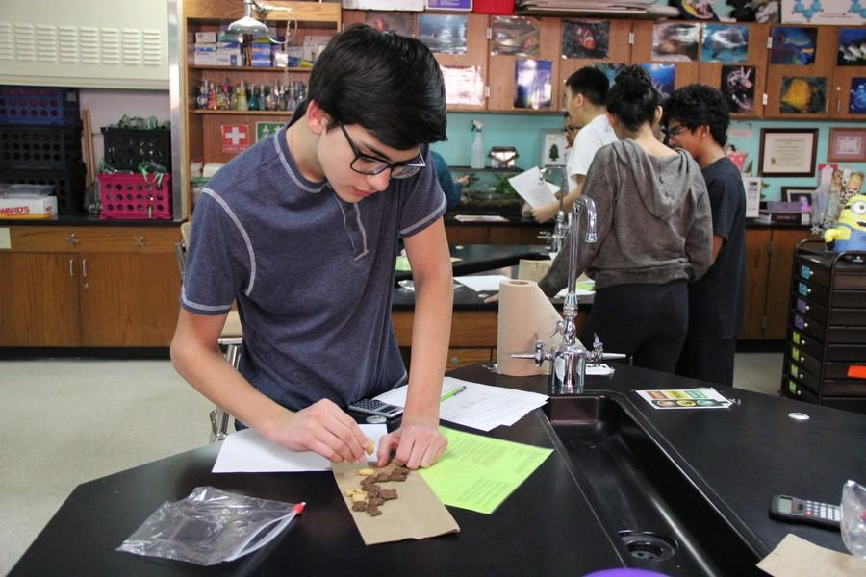 |  | Lesson Look Fors  Look for teachers to:  - Allow students to productively struggle with the content, using accountable talk moves to facilitate the lesson.  - Asking probing questions throughout the presentation that pushes students’ thinking.  Look for students to:  - Ask clarifying questions regarding what they are learning  - Write in complete sentences  Students Do and Know
   | - Analyze collected data on a population of “quackers.”  - Create visual representations of data.
   | - An adaptation is a trait that an individual is born with that either gives it an advantage or disadvantage in an environment.  - Evolution is a change in gene frequencies in a population over time.  - Natural selection is a type of evolution where certain traits (adaptations) give some populations reproductive success.  - Fitness is the ability to produce children.  - A population is a group of individuals of the same species.

Lessons #2: Cottontails Activity |  | Date:
Objective  SWBAT: Investigate how a population evolves over time due to random mutations and environmental pressures.  Standards  B.10.A – analyze and evaluate how natural selection produces change in populations and not in individuals  B.10.B – analyze and evaluate how the elements of natural selection, including inherited variation, the potential of a population to produce more offspring than can survive, and a finite supply of environmental resources, result in differential reproductive success  Vocabulary  adaptation  fitness  natural selection  population  adaptation  environmental resource  fitness  inherited variation  natural selection  reproductive success  mutation  Science Practices  - Asking Questions  - Developing and Using Models  - Planning and Carrying Out Investigations  - Using Mathematics  - Constructing Explanations  - Engaging in Argument from Evidence  - Communicating Information | Instructional Notes  This activity is designed to introduce the concept of natural selection. One of the main points of this activity is to help students see that a single organism cannot adapt to its environment, but that it will survive if it possesses a beneficial  adaptation. The data collected in this activity can be used as a reference point for terms used during presentations on evolution and speciation.  Day 2: Students participate in a guided inquiry activity using a computer simulation to investigate the survivability of a population of “bunnies” under several different mutations and population limiting factors.  Day 3: Students continue using the Natural Selection simulation from PhET, but today they are creating their own question and using the simulation to test it out.  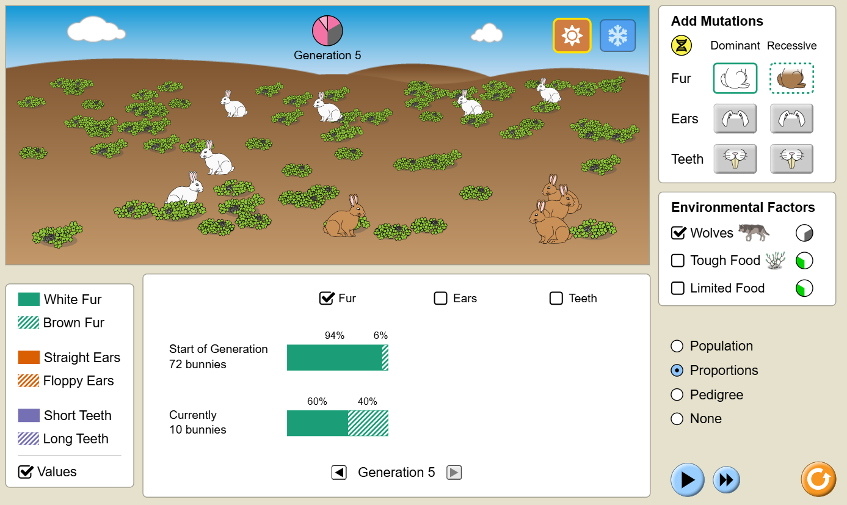 |  | Lesson Look Fors  Look for teachers to:  - Allow students to productively struggle with the content, using accountable talk moves to facilitate the lesson.  - Asking probing questions throughout the presentation that pushes students’ thinking.  Look for students to:  - Ask clarifying questions regarding what they are learning  - Write in complete sentences  Students Do and Know
  - Analyze data and identify trends.
  - Collaborate with peers to discuss similarities and differences in conclusions that were made.
  - An adaptation is a trait that an individual is born with that either gives it an advantage or disadvantage in an environment.
  - Evolution is a change in gene frequencies in a population over time.
  - Natural selection is a type of evolution where certain traits (adaptations) give some populations reproductive success.
  - Fitness is the ability to produce children.
  - A population is a group of individuals of the same species.
  - A mutation is change in the nucleotide sequence in DNA that may or may not produce a new trait.

Lesson #3: Population Variation Determination |  | Date:
Objective  SWBAT: Investigate, using collected data, how a population might change due to one or more types of natural selection.  Standards  B.10.C – analyze and evaluate how natural selection may lead to speciation  Vocabulary  adapt/adaptation  competition  diversity  gene frequency  habitat  mortality rate  natural selection  offspring  population  predator  prey  reproduction  stabilizing selection  disruptive selection  directional selection  Science Practices  - Asking Questions  - Developing and Using Models  - Planning and Carrying Out Investigations  - Using Mathematics  - Constructing Explanations  - Engaging in Argument from Evidence  - Communicating Information | Instructional Notes  In this activity, students take measurements on plant and student traits and perform calculations to examine the dispersion of the data. They will then construct a histogram of the class hand length data and use it to predict the outcome (graphically) of three scenarios involving the three modes of natural selection (stabilizing, directional, and disruptive).  Students will:  - Collect and statistically analyze leaf variation data  - Collect and statistically analyze hand variation data  - Make a histogram of hand data and use it to predict changes to the population due to different modes of natural selection  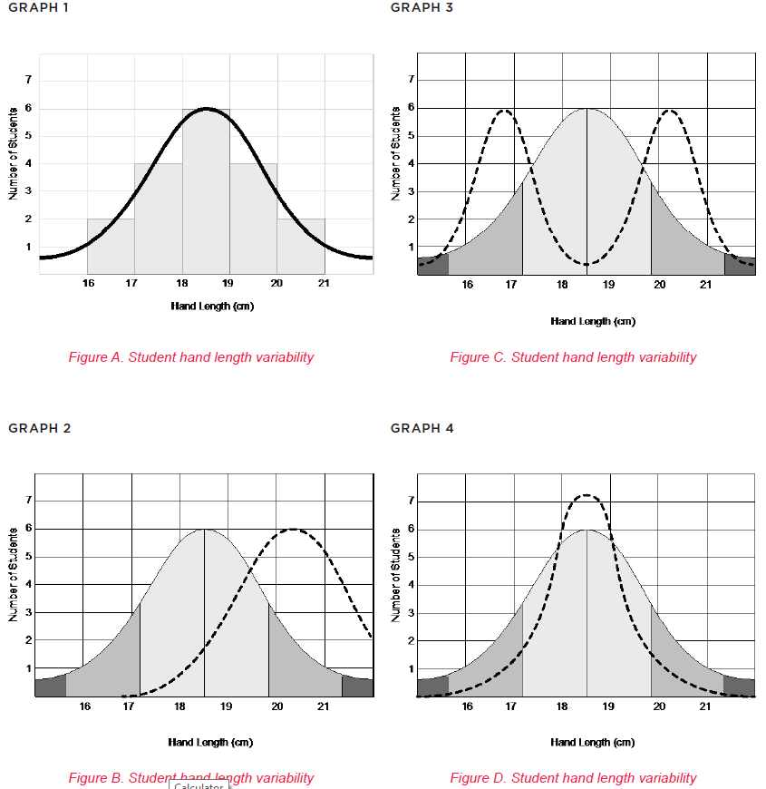 |  | Lesson Look Fors  Look for teachers to:  - Allow students to productively struggle with the content, using accountable talk moves to facilitate the lesson.  - Asking probing questions throughout the presentation that pushes students’ thinking.  Look for students to:  - Ask clarifying questions regarding what they are learning  - Write in complete sentences  Students Do and Know
  - Collect data.
  - Create models of data.
  - Analyze graphs for trends.
  - Natural selection is a type of evolution where certain traits (adaptations) give some populations reproductive success.
  - A population is a group of individuals of the same species.
  - Stabilizing selection is a type of natural selection that favors individuals with average or moderate traits and selects against extreme traits.
  - Disruptive selection is a type of natural selection where individuals with extreme traits are favored over those with intermediate traits.
  - Directional selection is a type of natural selection that occurs when a population favors one extreme phenotype over other phenotypes.

Lessons #4 and #5: Genetic Drift and Gene Flow Activity |  | Date:
Objective  SWBAT: Investigate the change in allele frequencies are changed over time due to different types of population changes (gene flow and genetic drift).  Standards  B.10.D – analyze evolutionary mechanisms other than natural selection, including genetic drift, gene flow, mutation, and genetic recombination, and their effect on the gene pool of a population.  Vocabulary  artificial selection  gene flow  genetic drift  genetic variation  mutation  non-random mating  recombination  Science Practices  - Asking Questions  - Developing and Using Models  - Planning and Carrying Out Investigations  - Using Mathematics  - Constructing Explanations  - Engaging in Argument from Evidence  - Communicating Information | Instructional Notes  In this simulation, students investigate how gene frequencies change due to different types of evolution (genetic drift and gene flow).  Students will:  - Simulate different populations, each with different and distinct allele combinations  - Use the class data to calculate the genotypic frequency for each population in each scenario  - Calculate the frequency of each allele using information from the genotypic frequencies of each population  Day 4: Then they will engage in a hands-on-minds-on activity where they simulate a population undergoing natural selection and gene flow.  Day 5: Students will engage in the same activity as yesterday but today they will engage in simulating the instability of small populations (genetic drift), by investigating both the bottleneck effect and founder effect.  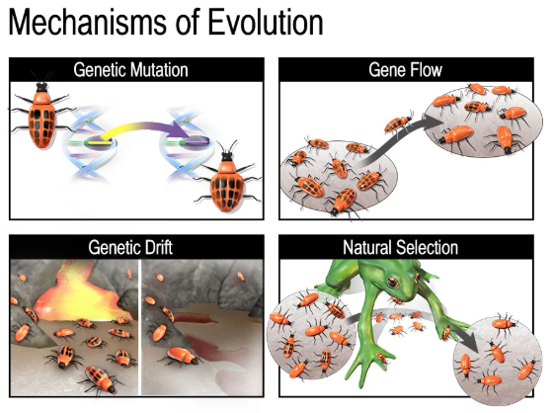 |  | Lesson Look Fors  Look for teachers to:  - Allow students to productively struggle with the content, using accountable talk moves to facilitate the lesson.  - Asking probing questions throughout the presentation that pushes students’ thinking.  Look for students to:  - Ask clarifying questions regarding what they are learning  - Write in complete sentences  Students Do and Know
  - Analyze data and identify trends.
  - Collaborate with peers to discuss similarities and differences in conclusions that were made.
  - Evolution is a change in gene frequencies in a population over time.
  - A population is a group of individuals of the same species.
  - A mutation is change in the nucleotide sequence in DNA that may or may not produce a new trait.
  - Gene flow is the movement of alleles into or out of a population.
  - Genetic drift is the when a population suddenly decreases in size and therefore the gene pool gets smaller and less diverse.
Lesson #6: Tree of Life |  | Date:
Objective  SWBAT: Investigate how cladograms and phylogenetic trees change shape depending on the type of evolutionary evidence used.  Standards  B.9.A – analyze and evaluate how evidence of common ancestry among groups is provided by the fossil record, biogeography, and homologies, including anatomical, molecular, and developmental  Vocabulary  analogous structure  ancestor  biogeography  descended  developmental homology  DNA sequence  embryo  evolution  fossil record  genus  homologous structure  molecular homology  offspring  phylogenetic  Science Practices  - Asking Questions  - Developing and Using Models  - Planning and Carrying Out Investigations  - Using Mathematics  - Constructing Explanations  - Engaging in Argument from Evidence  - Communicating Information | Instructional Notes  This lesson will review molecular biology and genetics, as well as the impact both have on evolutionary relationships. Students attempt to create a cladogram for 14 organisms based first on physical similarities, then pre-lab information, and finally using NCBI protein sequences of cytochrome c. The BLAST information should give them a more accurate evolutionary relationship.  Students will:  - Practice creating a cladogram of organisms based on given physical traits  - Create a cladogram using pictures of organisms  - Compare the second cladogram with the information from the pre-lab and recreate the cladogram  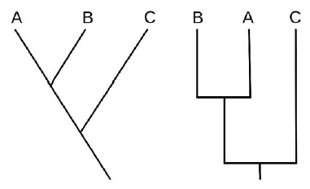 |  | Lesson Look Fors  Look for teachers to:  - Allow students to productively struggle with the content, using accountable talk moves to facilitate the lesson.  - Asking probing questions throughout the presentation that pushes students’ thinking.  Look for students to:  - Ask clarifying questions regarding what they are learning  - Write in complete sentences  Students Do and Know
  - Analyze data and identify trends.
  - Collaborate with peers to discuss similarities and differences in conclusions that were made.
  - An adaptation is a trait that an individual is born with that either gives it an advantage or disadvantage in an environment.
  - A cladogram is a diagram that shows the evolutionary relationships between organisms by grouping them into clades based on shared characteristics.
  - Homology is the study of similarities between organisms that are due to shared ancestry.

Lesson #7: Evidence for Evolution Activity |  | Date:
Objective  SWBAT: Investigate the different types of evidence used to support evolution.  Standards  B.9.A – analyze and evaluate how evidence of common ancestry among groups is provided by the fossil record, biogeography, and homologies, including anatomical, molecular, and developmental  Vocabulary  analogous structure  ancestor  biogeography  descended  developmental homology  DNA sequence  embryo  evolution  fossil record  genus  homologous structure  molecular homology  offspring  phylogenetic  Science Practices  - Developing and Using Models  - Constructing Explanations  - Engaging in Argument from Evidence  - Communicating Information | Instructional Notes  The goal of this activity is for students to familiarize themselves with the different pieces of evidence used to support evolution over time.  Activity #1: Students watch a video that walks them through the different pieces of evidence.  Activity #2: Students participate in a paper-based activity where they investigate the different pieces of evidence below  - fossil record  - embryology  - comparative anatomy (morphology)  - vestigial structures  - molecular biology  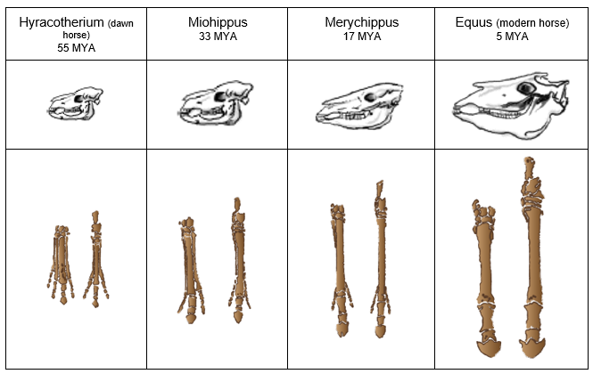 |  | Lesson Look Fors  Look for teachers to:  - Allow students to productively struggle with the content, using accountable talk moves to facilitate the lesson.  - Asking probing questions throughout the presentation that pushes students’ thinking.  Look for students to:  - Ask clarifying questions regarding what they are learning  - Write in complete sentences  Students Do and Know
  - Analyze data and identify trends.
  - Collaborate with peers to discuss similarities and differences in conclusions that were made.
  - The fossil record is a collection of fossils that documents the history of life on Earth.
  - Biogeography is the branch of biology that deals with the geographical distribution of plants and animals.
  - Homology is the study of similarities between organisms that are due to shared ancestry.
  - Anatomical homology deals with similarities and differences in morphology (anatomical traits.)
  - Developmental homology deals with embryological similarities and differences.
  - Molecular homology deals with similarities and differences in DNA, RNA, and proteins.

Lesson #8: Rates of Evolution |  | Date:
Objective  SWBAT: Model the differences between gradualism and punctuated equilibrium.  Standards  B.9.B – examine scientific explanations for varying rates of change such as gradualism, abrupt appearance, and stasis in the fossil record  Vocabulary  Gradualism  Punctuated equilibrium  Fossil record  Stasis  Transitional fossils  Science Practices  - Developing and Using Models  - Planning and Carrying Out Investigations  - Using Mathematics  - Constructing Explanations  - Engaging in Argument from Evidence  - Communicating Information | Instructional Notes  Activity #1: Students watch a video showing the difference between gradualism and punctuated equilibrium. They will take guided notes while watching the video. NOTE: This is a video that was made for AP Biology, but it is on level with where students need to be in order to be successful on the STAAR exam, i.e., it is a less rigorous take on rates of change that AP Biology would need to be at.  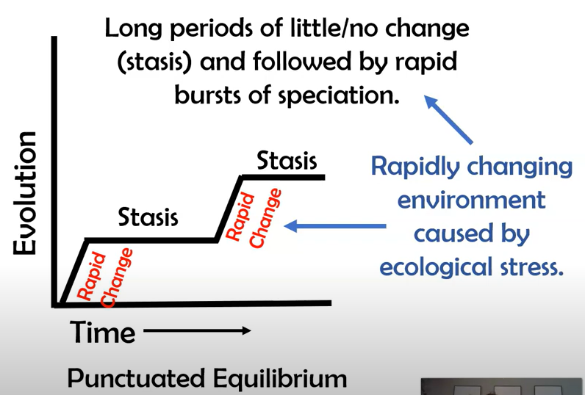  Activity 2: Students analyze fictional fossils, along with their age, to determine how these different species evolved over time. They use their analysis to show both instances of gradualism and punctuated equilibrium.  Students will:  - analyze characteristics of fossils  - compare placement of fossils and determine relative ages  - develop a model evolutionary tree based on the morphology and age of fossils |  | Lesson Look Fors  Look for teachers to:  - Allow students to productively struggle with the content, using accountable talk moves to facilitate the lesson.  - Asking probing questions throughout the presentation that pushes students’ thinking.  Look for students to:  - Ask clarifying questions regarding what they are learning  - Write in complete sentences  Students Do and Know
  - Derive meaning from a video.
  - Analyze visual representations and identify trends seen over time.
  - Gradualism is the hypothesis that evolution proceeds chiefly by the accumulation of gradual changes (in contrast to the punctuated equilibrium model).
  - Punctuated equilibrium is a theory in evolutionary biology that describes how species evolve through long periods of stability and short periods of rapid change.
  - Stasis is a period of time with little to no change.

Lesson #9: Salamander Evolution |  | Date:
Objective  SWBAT: Investigate how reproductive isolation can cause salamander populations to evolve into separate species.  Standards  B.10.C – analyze and evaluate how natural selection may lead to speciation  Vocabulary  adapt/adaptation  competition  diversity  gene frequency  habitat  mortality rate  natural selection  offspring  population  predator  prey  reproduction  speciation  species  Science Practices  - Asking Questions  - Developing and Using Models  - Planning and Carrying Out Investigations  - Using Mathematics  - Constructing Explanations  - Engaging in Argument from Evidence  - Communicating Information | Instructional Notes  In the lesson on archaeopteryx, students were introduced to how scientists use shared morphological characteristics in the fossil record to establish common ancestry. Now that students have gained a deeper understanding of the mechanisms that allow for adaptations and species characteristics to change over time through natural selection, they are ready to more deeply explore the process of speciation. This short investigation into California salamanders of the genus in Ensatina introduces students to ways in which reduced gene flow can serve as a mechanism for speciation – in this case, in the form of reproductive isolation due to geographic barriers. This lesson should be completed before any formal discussion about speciation.  Activity #1: Students watch and discuss a video clip that introduces the context and ideas about geographic mechanisms of adaptive divergence for California salamanders in the genus Ensatina.  Activity #2: Students work in groups to examine further research on the evolution of the salamanders and how reproductive isolation may also play a role in keeping these subspecies distinct, even in areas where interbreeding can occur. Students then do a gallery walk to examine and discuss peers’ ideas about the process of speciation. |  | Lesson Look Fors  Look for teachers to:  - Allow students to productively struggle with the content, using accountable talk moves to facilitate the lesson.  - Asking probing questions throughout the presentation that pushes students’ thinking.  Look for students to:  - Ask clarifying questions regarding what they are learning  - Write in complete sentences  Students Do and Know
  - Analyze data and make valid conclusions.
  - Analyze research and construct explanations.
  - Collaborate with peers on similar vs different conclusions.
  - An adaptation is a trait that an individual is born with that either gives it an advantage or disadvantage in an environment.
  - Evolution is a change in gene frequencies in a population over time.
  - Natural selection is a type of evolution where certain traits (adaptations) give some populations reproductive success.
  - A population is a group of individuals of the same species.
  - Species is a term used to describe a category of living things that are related and can produce fertile offspring and are reproductively isolated from other such groups.
  - Speciation is the evolutionary process that creates new species by splitting a population into two or more genetically independent lineages.

Lesson #10 and #11: Speciation Lab |  | Date:
Objective  SWBAT: Model how a frog population can, over time, evolve into separate species.  Standards  B.10.C – analyze and evaluate how natural selection may lead to speciation  Vocabulary  adapt/adaptation  competition  diversity  gene frequency  habitat  mortality rate  natural selection  offspring  population  predator  prey  reproduction  speciation  species  Science Practices  - Asking Questions  - Developing and Using Models  - Planning and Carrying Out Investigations  - Using Mathematics  - Constructing Explanations  - Engaging in Argument from Evidence  - Communicating Information | Instructional Notes  Day 13  Activity 1: Students read an intro to an activity while annotating what they have read and use the text and their notes/annotations to answer a series of intro questions.  Activity 2: Students simulate speciation within a population of hypothetical frogs using dice, and the lists of mutations on the activity.  Day 14  Activity 2: Students finish any data collection and/or analysis they still need to complete from the previous day.  Activity 3: Students complete an activity where they analyze data (by creating a graph) and determine which type of natural selection is being exhibited and then finish with a writing activity.  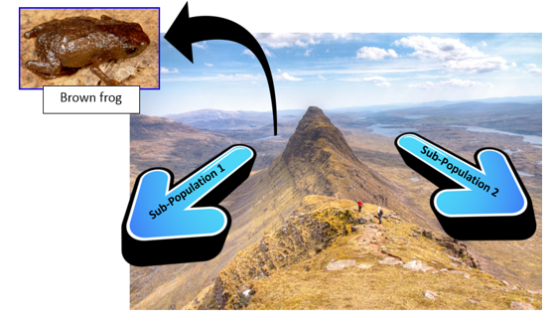 |  | Lesson Look Fors  Look for teachers to:  - Allow students to productively struggle with the content, using accountable talk moves to facilitate the lesson.  - Asking probing questions throughout the presentation that pushes students’ thinking.  Look for students to:  - Ask clarifying questions regarding what they are learning  - Write in complete sentences  Students Do and Know
  - Create a model of speciation.
  - Analyze collected data.
  - An adaptation is a trait that an individual is born with that either gives it an advantage or disadvantage in an environment.
  - Evolution is a change in gene frequencies in a population over time.
  - Natural selection is a type of evolution where certain traits (adaptations) give some populations reproductive success.
  - A population is a group of individuals of the same species.
  - Species is a term used to describe a category of living things that are related and can produce fertile offspring and are reproductively isolated from other such groups.
  - Speciation is the evolutionary process that creates new species by splitting a population into two or more genetically independent lineages.

Day 12 | Review Day
Day 13 | Administer Unit Exam 7

UNPACKED STANDARDS
Focus standards for this unit.

Standards Clarification
Standards | Notes/Explanations/Examples
B.9.A – analyze and evaluate how evidence of common ancestry among groups is provided by the fossil record, biogeography, and homologies, including anatomical, molecular, and developmental | Standard breakdown:  - Analyze [and evaluate] how evidence of common ancestry among groups is provided by:  - the fossil record  - biogeography  - anatomical homologies  - molecular homologies  - developmental homologies  Major concepts in this standard include:  - Evolution  - Common ancestry  - Fossil record  - Biogeography  - Homologies  When you teach this concept, remember to:  - Vary the charts, diagrams, and tables used to determine relatedness.  - Provide opportunities to compare homologous structures, including anatomical, molecular, and developmental.  - Provide opportunities to compare fossil records on maps to determine ancestry and use dendrograms/ cladograms in context.  - Explore animals with similar features and investigate how genome maps determine ancestry.  Students may make the following mistakes:  - Confusing cladograms with dendrograms  - Not recognizing examples where environmental factors caused changes in the fossil records or when geographic isolation affects speciation  - Confusing homologous and analogous structures  - Incorrectly applying genome maps and molecular structures to determine ancestry
B.9.B – examine scientific explanations for varying rates of change such as gradualism, abrupt appearance, and stasis in the fossil record | Supports: This standard directly supports B.9(A) by examining stasis in the fossil record to evaluate evidence of common ancestry.  Instructional Implications  The fossil record shows that organisms have changed over very long periods of time. Understanding how natural selection can produce changes in populations is an extension of analyzing and evaluating the relationship of natural selection to adaptations among species. It is important for students to understand that populations are part of ecosystems, and natural selection affects ecosystem stability.  When you teach this concept, remember to:  - Vary the visuals for fossil records (e.g., phylogenetic trees, cladograms, dendrograms, spindle diagrams, and timelines), and have students explain and draw conclusions from the visuals.  - Provide opportunities for students to interpret population data from graphs and diagrams and evaluate groups in the fossil record.  - Provide opportunities for students to model, infer, and explain changes in the fossil record for both plants and animals.  Students may make the following mistakes:  - Misinterpreting cladograms  - Not being able to recognize and understand scientific explanations for evolutionary trends and the fossil record  - Thinking that natural selection is synonymous with adaptations or not understanding it is a process that occurs over time
B.10.A – analyze and evaluate how natural selection produces change in populations and not in individuals | Supports: This standard supports B.10(C) by connecting natural selection in a species to changes in populations.  When you teach this concept, remember to:  - Provide hands-on opportunities for students to observe selection advantages.  - Explore all types of selection in plants and animals: disruptive, direction, and stabilizing.  - Investigate how allele frequency can change populations.  - Emphasize that adaptations can result in both increased and decreased fitness of organisms.  Students may make the following mistakes:  - Thinking that natural selection acts on genotypes rather than phenotypes  - Thinking that gene variations do not cause natural selection in populations  Not recognizing environmental factors that cause adaptations
B.10.B – analyze and evaluate how the elements of natural selection, including inherited variation, the potential of a population to produce more offspring than can survive, and a finite supply of environmental resources, result in differential reproductive success | Supports  This standard directly supports B.10(A) by evaluating each of the elements of natural selection and how they affect a species.  When you teach this concept, remember to:  - Vary the visuals used to analyze the elements of natural selection.  - Provided opportunities to observe how variation in a species is key to species survival. Create opportunities for students to make connections among natural selection and mutations, recombination, and migration.  Students may make the following mistakes:  - Thinking that mutations do not affect natural selection  Not recognizing inherited variation as the biggest factor in new species survival
B.10.C – analyze and evaluate how natural selection may lead to speciation | Standard breakdown:  - Analyze how natural selection may lead to speciation  - Evaluate how natural selection may lead to speciation  Major concepts in this standard include:  - Natural selection  - Speciation  Instructional Implications  Adaptations can manifest from both internal and external factors, and they can lead to new and distinct species. Analyzing and evaluating the relationship of natural selection to adaptations and species diversity is key to evolutionary theory and supports the concept of ecosystem stability.  When you teach this concept, remember to:  - Evaluate how generic adaptations relate to natural selection using allele frequency.  - Provide opportunities for students to evaluate plant and animal adaptations using varied visuals, charts/tables, and graphs, and analyze if the adaptation is beneficial or harmful.  - Explore plant and animal adaptations as they relate to species diversity and reproduction.  - Analyze how geographic and behavioral isolation contribute to natural selection.  Students may make the following mistakes:  Not recognizing that species diversity supports natural selection  Thinking that mutations in genes are always harmful  Not recognizing that adaptations for seed dispersal in plants help ensure species survival through natural selection by passing these adaptations on to future generations
B.10.D – analyze evolutionary mechanisms other than natural selection, including genetic drift, gene flow, mutation, and genetic recombination, and their effect on the gene pool of a population. | Supports  This standard supports B.10(C) by further analyzing the relationship of natural selection to the evolutionary mechanisms causing the adaptations.  When you teach this concept, remember to:  - Provide opportunities for students to explore different mechanisms of evolution and analyze their causes.  - Have students model/illustrate different mechanisms of evolution and provide written explanations.  - Have students analyze genetic drift, gene flow, mutations, and recombination.  Students may make the following mistakes:  - Not associating natural selection with mechanisms of evolution  - Confusing genetic drift and gene flow

